CHAPTER 4: Ecosystems
Worksheet 4.3

Ocean explorations
Science Quest 7: pages 122–127
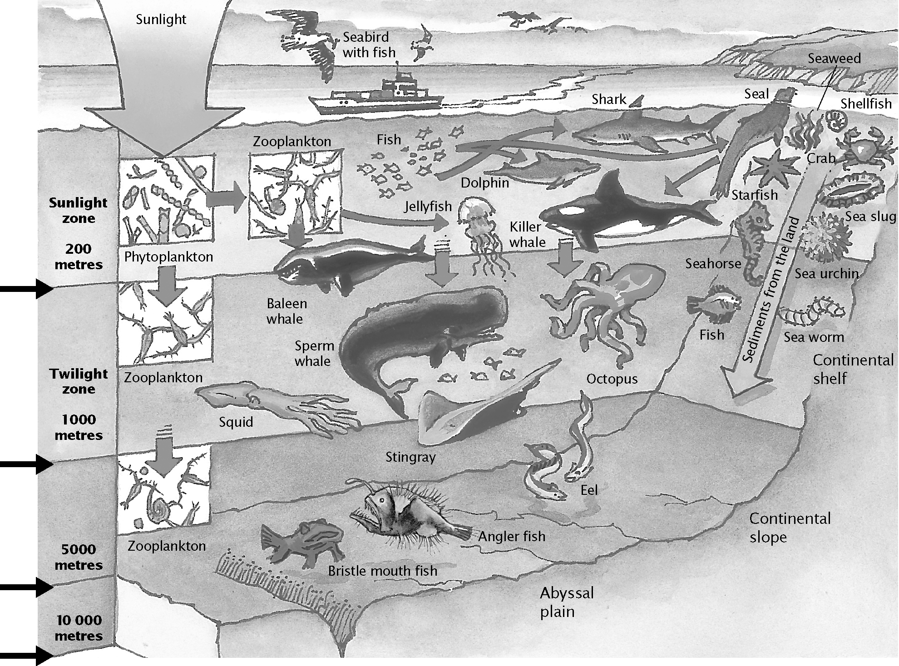
Answers
22°C
6°C
3°C
3°C
A huge variety of amazing creatures live in our oceans. Imagine you have been invited on board a submersible craft that is capable of exploring the sea floor thousands of metres below the ocean surface. As you descend, what changes will you observe in the animals and plants that inhabit the ocean? Using the diagram above as a guide, write a brief description of how the plants and animals change along your journey to the seabed. Think about the size, shape, colour and variety of organisms at different depths. Write your descriptions in the table.

Changes observed in animals
As we travel deeper into the ocean, animals show adaptations for life in darkness, cold water and high pressure. Many of the animals would have large eyes, helping them see in the dark waters. Some will be small, dark and thin to help camouflage them. Other animals will glow in the dark. Because there is less plant food, animals in the ocean depths will not be as active because they have less energy available. Carnivores may have large mouths and jaws to capture prey with less energy expenditure. Once we get past the ‘twilight zone’, animals may not have eyes at all as there is no light this far down. Most animals at this depth will be invertebrates due to high water pressure.

CHAPTER 4: Ecosystems PAGE 2
Worksheet 4.3

Changes observed in plants
As we travel from the sunlight zone to the twilight zone there is less plant life because there is less sunlight available for photosynthesis for plants to produce food. There will be no plants in the lower levels of the twilight zone or deeper.

Now consider the non-living parts of the
ocean — light, temperature, water pressure and available oxygen. On the set of axes below, draw a graph that describes each of the non-living parts in the ocean and how they change at different depths. (Use the information in the diagram on the first page of this worksheet to help you.) Use different coloured lines for each non-living item described by the graph. Fill in the key. Predict how each factor will change at a depth of
12 000 m by using a pencil to continue each line.

Graph of light, temperature, water pressure and oxygen (answers may vary between students but should follow patterns described below:

Light: should start high and gradually drop down to low by 1000 m.
Temperature: should start high and drop to two-thirds of axis at 1000 m, then one-third axis at 5000 to 10 000 m.
Oxygen: should start halfway up axis and drop to quarter of axis by 1000 m, then tail of towards low by about 5000 m.
Pressure: should start low and rapidly increase to halfway up axis by 1000 m and reach top of axis by 10 000 m.

Imagine you are a sea creature.
(a) What problems would you have living at the bottom of the ocean?
Answers will vary.

(b) What special features do you have that enable you to live at these amazing depths?

Answers will vary.

(c) Draw a portrait of yourself in the space below. Label your special features.
Answers will vary.

